[E106] Boil inlet valve

At first, switch on the machine, select the service menu and open all the valves. (valves can be removed only in open position)

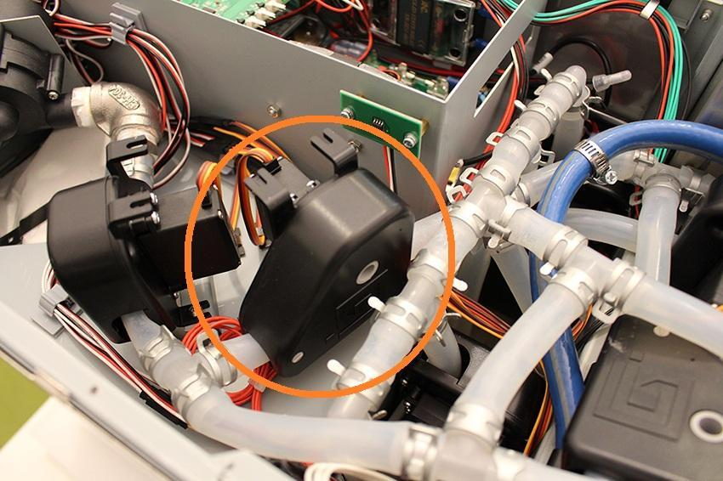

Unscrew the indicated screws and pull off the indicated hose clamp and silicone tube from the fitting.

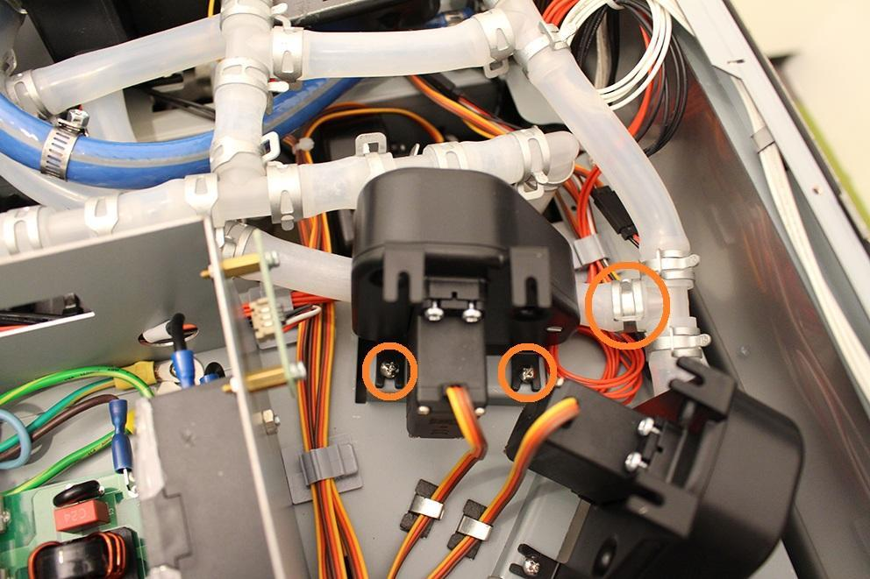

Disconnect the plug of the valve from the MCU. Now you can remove the valve.

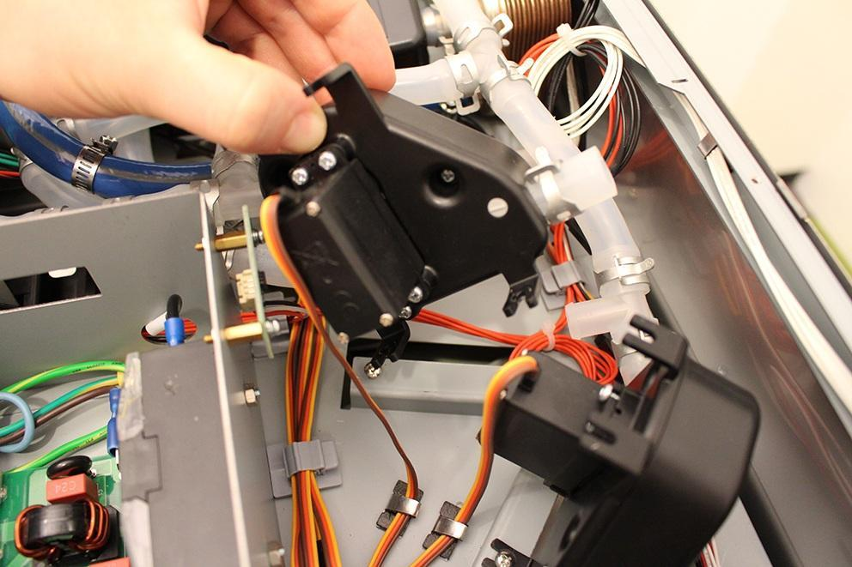

After you removed the valve, please check if the inner wall of the silicone tube is clinged together. If it is clinged together, do not change the valve, you only have to do is to separate the inner walls.

Reassemble consists of the same steps in reverse.